Task 3b:

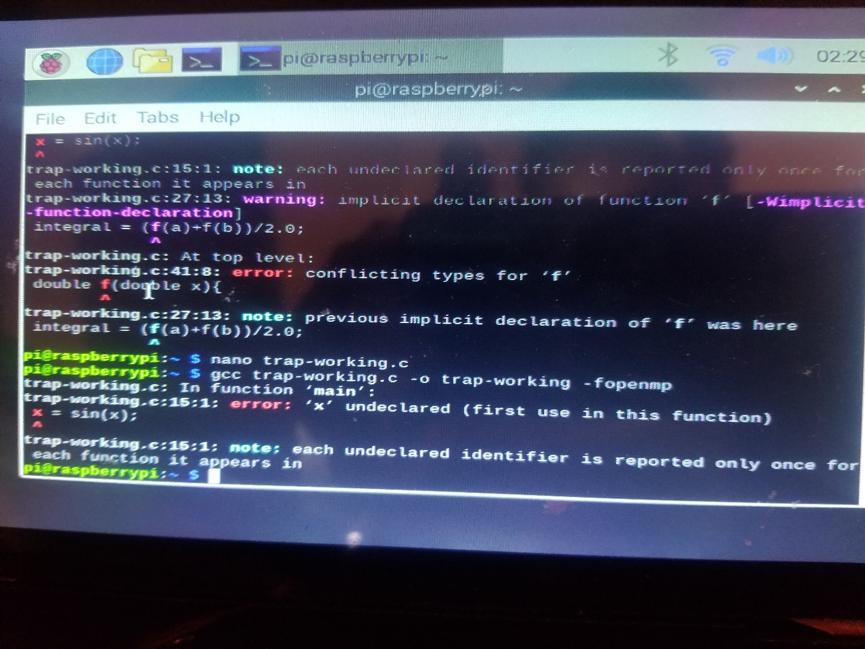

Unfortunately, we couldn’t get the program to work to satisfaction but because the Arm is not recognizing the math library so we had to declare sin of x originally in the main function. However, this complicated other issues in our programs. Objective, however, was to see how new statement added would thread out and execute.

* On this task, we will probably come together as a team to figure what is wrong with either the function or the library. Just unfortunate we cant figure it out sooner.

NANO BARRIER.C

Here is the output before the //pragma omp barrier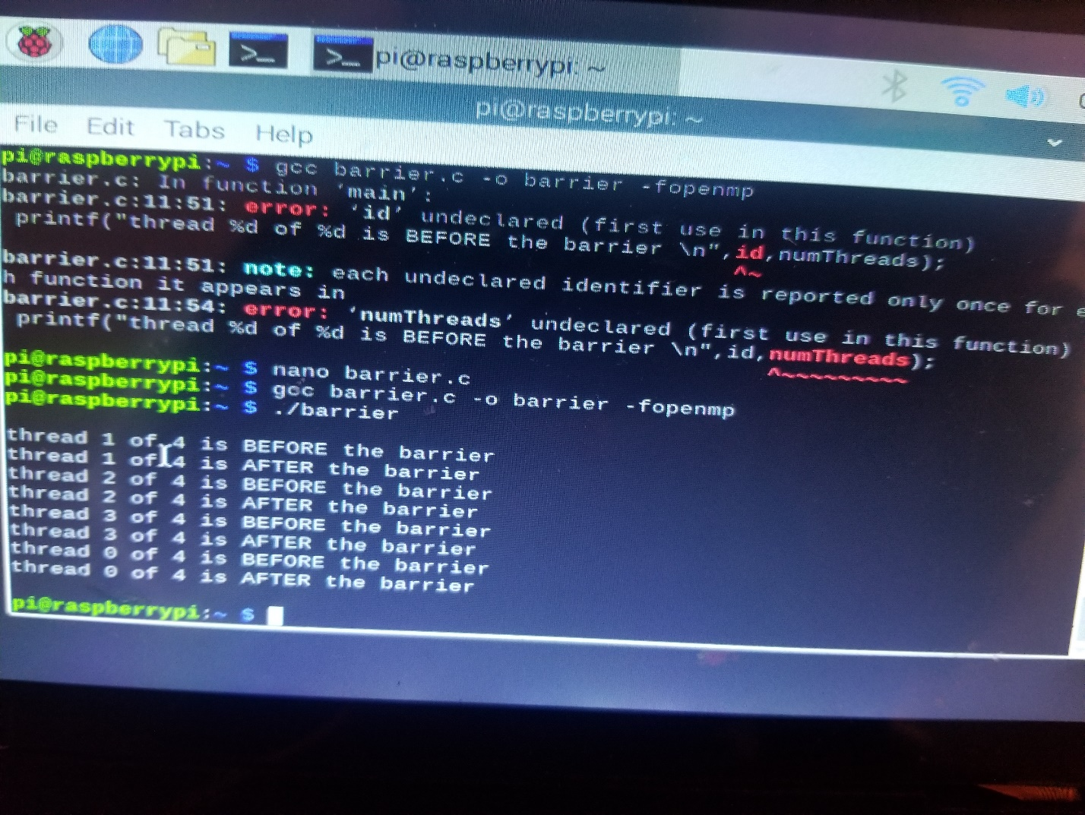

Here is the output after the new statement is input. 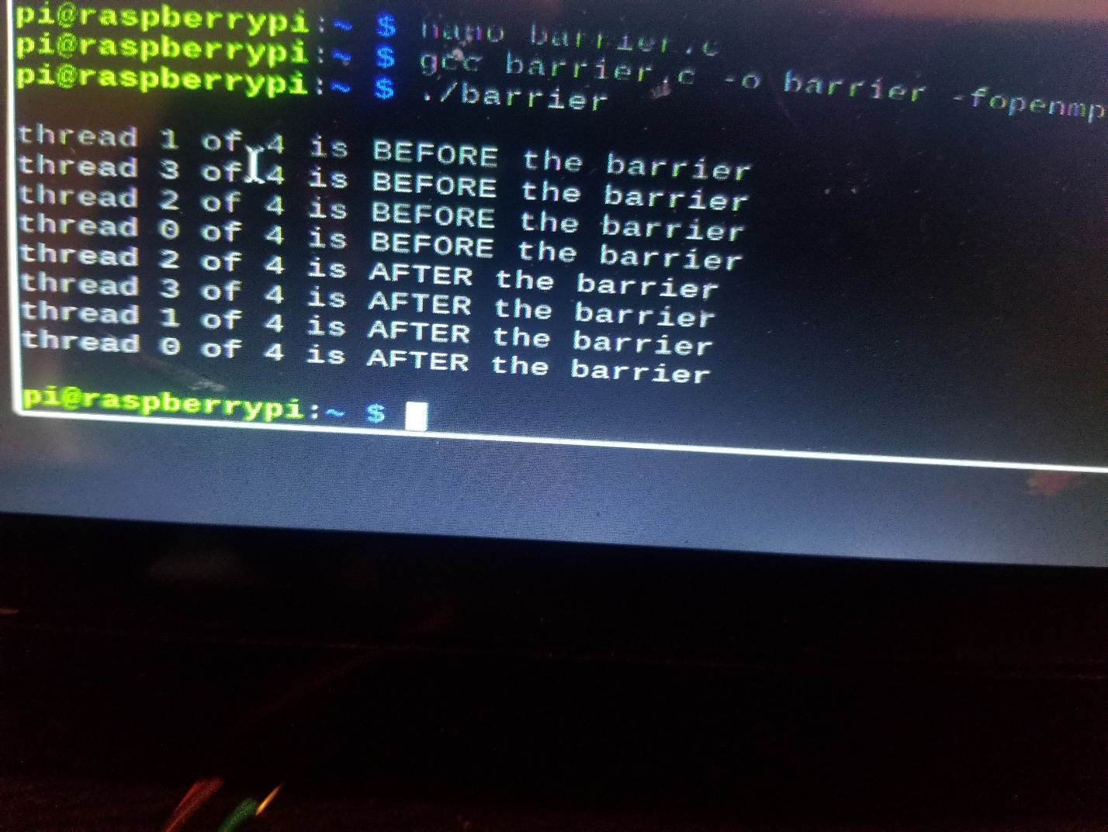

Task 3:

Master without the pragma omp parallel line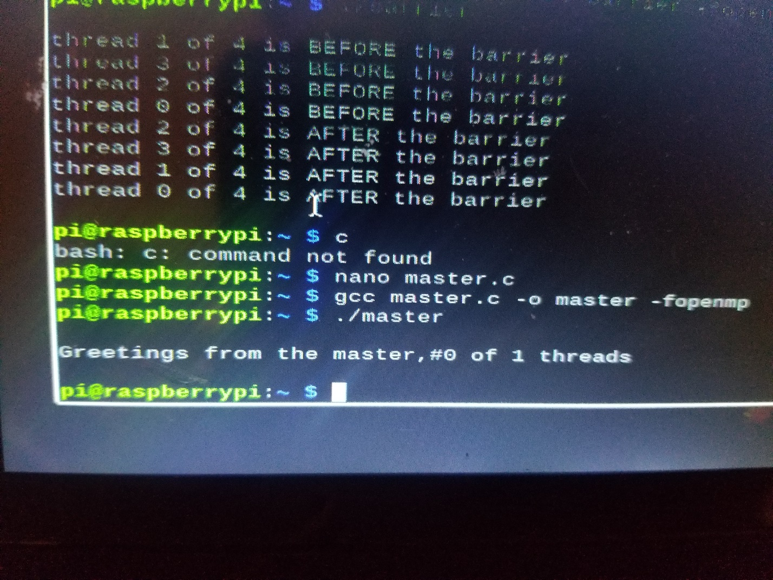

With the pragma omp parallel